

Year 7 Science 2020 Name: _________________

**Earth and Space 2 Test**

**SECTION 1: MULTIPLE CHOICE** (1 mark each)

1. Rocks are weathered to form materials that can then form part of a soil. Soils would therefore contain the following material that was originally part of the rock:
   1. Air
   2. Water
   3. Minerals
   4. Humus
2. Which of these is a non renewable energy source:
3. Petrol
4. Wind
5. Solar
6. Water
7. Soils are not renewable because they:
   1. can be eroded.
   2. are replaced too slowly.
   3. are formed from weathering of rocks.
   4. can be weathered.
8. Select the alternative that cannot be used to produce biomass.
   1. Decomposing fruit peelings and grass clippings
   2. Human sewage and animal wastes
   3. Fermented sugarcane
   4. Recycled aluminium
9. Which of the following is true about the Sun?
   1. Plants use sunlight to produce food.
   2. It warms the Earth’s atmosphere.
   3. It is a renewable resource.
   4. All of the above.

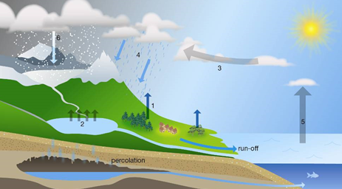*For Question 6 and 7 use the diagram to answer the questions*

1. State the process occurring at position 2.
   1. Precipitation
   2. Evaporation
   3. Condensation
   4. Transpiration
2. State the process that has occurred at position 1.
   1. Precipitation
   2. Evaporation
   3. Condensation
   4. Transpiration
3. State the largest source of evaporation in the water cycle.
   1. The oceans, because they are the largest bodies of water
   2. Vegetation, because the leaves of trees and other plants have such a large surface area
   3. Turbulent rivers and streams and waterfalls where there is a lot of spray going into the air
   4. Spray irrigation of large agricultural areas
4. Human activities have upset the natural water cycle in many places. Select the human activity that is an attempt to restore an aspect of the natural water cycle.
   1. Irrigation of crops
   2. Replacing forest with food crops
   3. Building of dams
   4. Construction of rain gardens

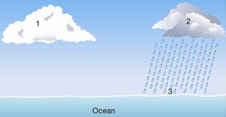

1. Using the information provided in the diagram, identify which of the following statements is *untrue*.
   1. The air at 1 is saturated.
   2. Evaporation is taking place at 3.
   3. Run-off will occur when the precipitation reaches 3
   4. The water droplets at 1 are smaller than at 2.

**SEMESTER TWO 2020**

**Investigating Science Test:**

**ANSWER BOOKLET**

**NAME:**

**FORM:** **DATE:**

Multiple Choice Short Answer Total

**/20**

**/10**

**/30**

**SECTION ONE:** Multiple choice answers

Cross (X) through the correct answer.

|  |  |  |  |  |
| --- | --- | --- | --- | --- |
| **1** | a | b | c | d |
| **2** | a | b | c | d |
| **3** | a | b | c | d |
| **4** | a | b | c | d |
| **5** | a | b | c | d |
| **6** | a | b | c | d |
| **7** | a | b | c | d |
| **8** | a | b | c | d |
| **9** | a | b | c | d |
| **10** | a | b | c | d |

**SECTION 2: WRITTEN**

**Write your answers in the spaces provided.**

1. **Explain** the difference between renewable and non-renewable energy. Give an example of each type of energy source. (3 marks)

_______________________________________________________________________________________________________________________________________________________________________________________________________________________________________________________________________________________________________________________________________________________________________________________

1. **Describe** two renewable energy sources of your choice. (4 marks)
2. ____________________________________________________________________________________________________________________________________________________________________________________________________________________________________________________________________________________________________
3. ____________________________________________________________________________________________________________________________________________________________________________________________________________________________________________________________________________________________________
4. **Match** the water cycle terms to their correct definition. (6 marks)

Condensation, Precipitation, Run – off, Evaporation, Transpiration, Percolation

|  |  |
| --- | --- |
| **Water Cycle Term** | **Definition** |
|  | The process of water soaking into the soil |
|  | Change of state from water vapour to liquid water |
|  | Any water falling out of the sky |
|  | Change of state from liquid water to water vapour |
|  | Water not absorbed by the soil |
|  | Evaporation of water from plants |

1. What is the difference between pervious and impervious rock? (2 mark)

_________________________________________________________________________________________________________________________________________________________________________________________________________________________________

1. Diagram below shows a soil profile

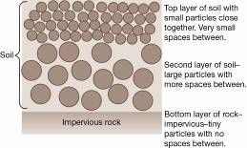

a) Describe what could happen to water falling on the surface of the soil. (2 marks)

_________________________________________________________________________________________________________________________________________________________________________________________________________________________________

b) Compare what would happen to the water if there was extremely heavy rainfall rather than a steady shower of rain. (2 marks)

____________________________________________________________________________________________________________________________________________________________________________________________________________________________________________________________________________________________________________

1. A student conducted an experiment to test the rate of percolation through different soil types.

She cut a hole in the bottom of a plastic cup and put a small piece of flyscreen over the hole. Then she put the cup in a retort stand and placed a beaker underneath the hole. A diagram of how she set up her equipment is shown on the right.

To test each soil, she filled the cup to the top and poured 100mL of water through the soil. She timed how long it took for the water to move through the soil to the beaker.

1. In this experiment, name (4 marks)

* the independent variable (changed) _________________________
* the dependent variable (measured) _________________________
* **two** controlled variables (kept the same) _________________________

_________________________

1. The student’s results are shown in the table below. Draw a column graph of her results.

(5 marks)

|  |  |
| --- | --- |
| **Soil Type** | **Time (minutes)** |
| Sand | 4 |
| Gravel | 1.5 |
| Clay | 10 |
| Loam | 7.5 |

|  |  |  |  |  |  |  |  |  |  |  |  |
| --- | --- | --- | --- | --- | --- | --- | --- | --- | --- | --- | --- |
|  |  |  |  |  |  |  |  |  |  |  |  |
|  |  |  |  |  |  |  |  |  |  |  |  |
|  |  |  |  |  |  |  |  |  |  |  |  |
|  |  |  |  |  |  |  |  |  |  |  |  |
|  |  |  |  |  |  |  |  |  |  |  |  |
|  |  |  |  |  |  |  |  |  |  |  |  |
|  |  |  |  |  |  |  |  |  |  |  |  |
|  |  |  |  |  |  |  |  |  |  |  |  |
|  |  |  |  |  |  |  |  |  |  |  |  |
|  |  |  |  |  |  |  |  |  |  |  |  |
|  |  |  |  |  |  |  |  |  |  |  |  |

1. Which soil did the water percolate through the fastest? (1 mark)

_______________________

1. Which soil did the water percolate through the slowest? (1 mark)

_______________________

**END OF TEST (OUT OF 39 MARKS)**